**Part 8 - Form Builder and Storing Data to Local Storage**

Here we’re going to learn about

1. Using Form Builder
2. Using alertify js (3rd party)
3. Wrapping alertify in other service
4. FORM BUILDER



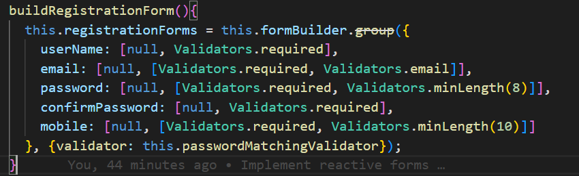

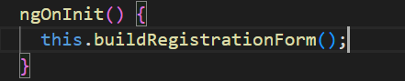

1. USING ALERTIFY JS
2. Open <https://alertifyjs.com/> and view on github to see NPM installation
3. Make sure, we are in project directory

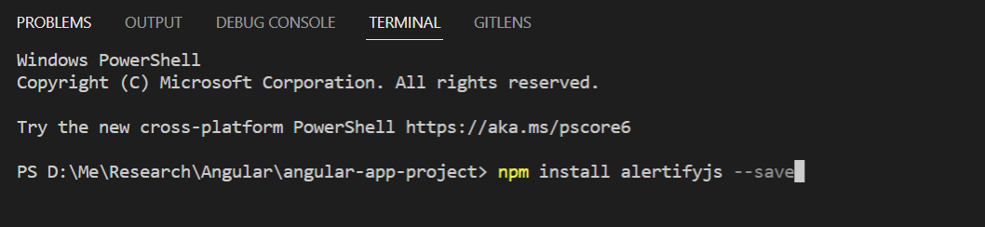

1. Check on node_modules directory

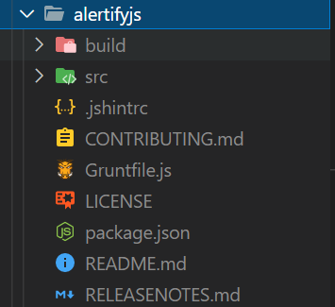

1. Import several css in order to use globally (only need to set in style.css)



1. Import alertify in user-register component (then we will face this error line)

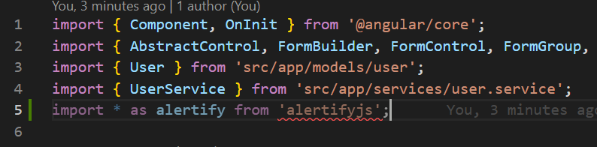

Please create this file under “src” directory



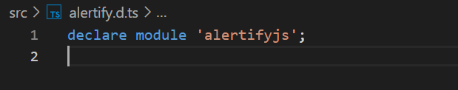

Open your component and add this alert code

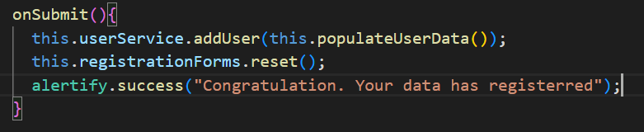

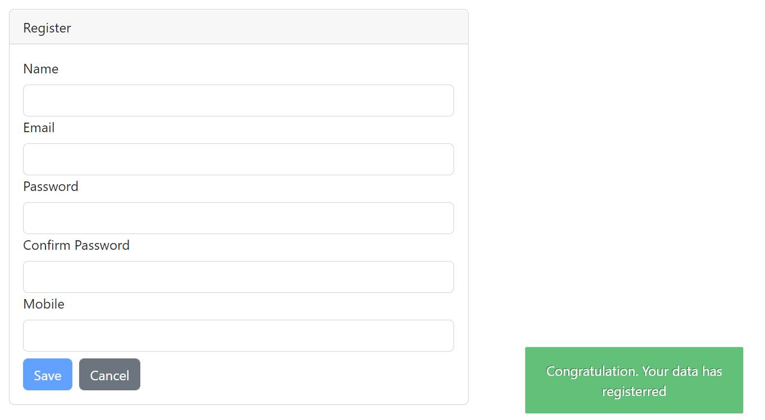

1. WRAPPING ALERTIFY IN OTHER SERVICES

Since the component only used for put business logic, then we need to separate this alert mechanism into different file / class.

1. Create AlertifyService

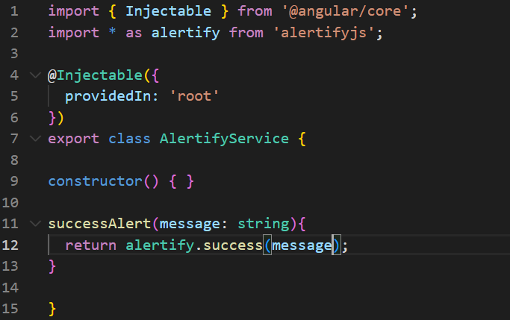

1. Register the service on app module



The question is why we need to register the service on app module instead of individual register in component?

When you register on app module, the service instance only created once in application. It means all of components use the service it will use the same instance. In other word we able to keep the state in our service. Whereas when we just import the service in component level, once the service is used in different component, it will be created the new instance